

# Heavy Weather

**Read about Prevention**

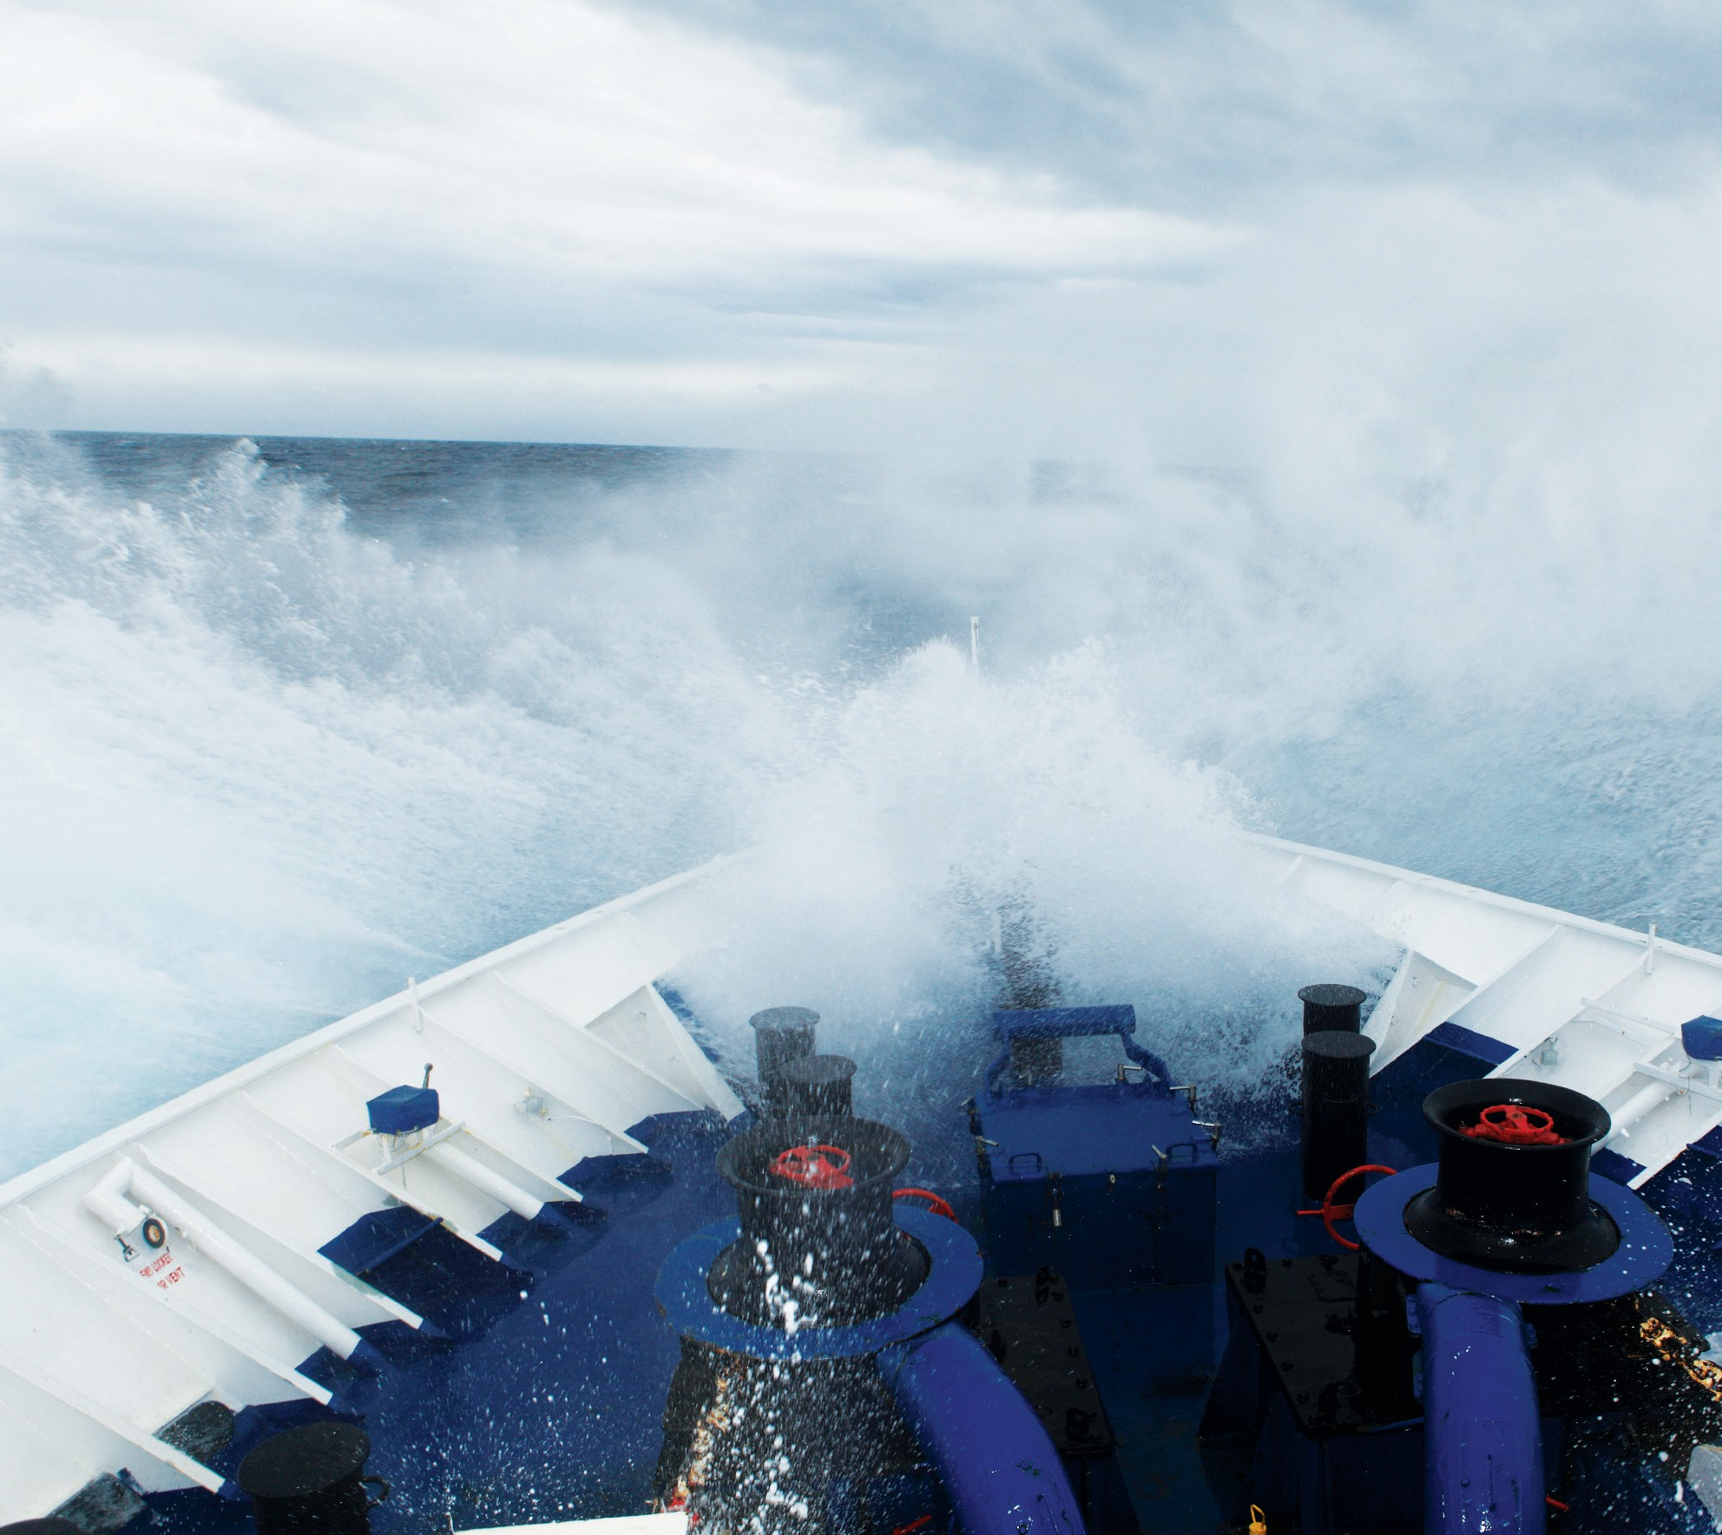

**at page 17**

**Read about Parametric rolling**

**at page 12**

# 2014

[**www.swedishclub.com**](http://www.swedishclub.com/)

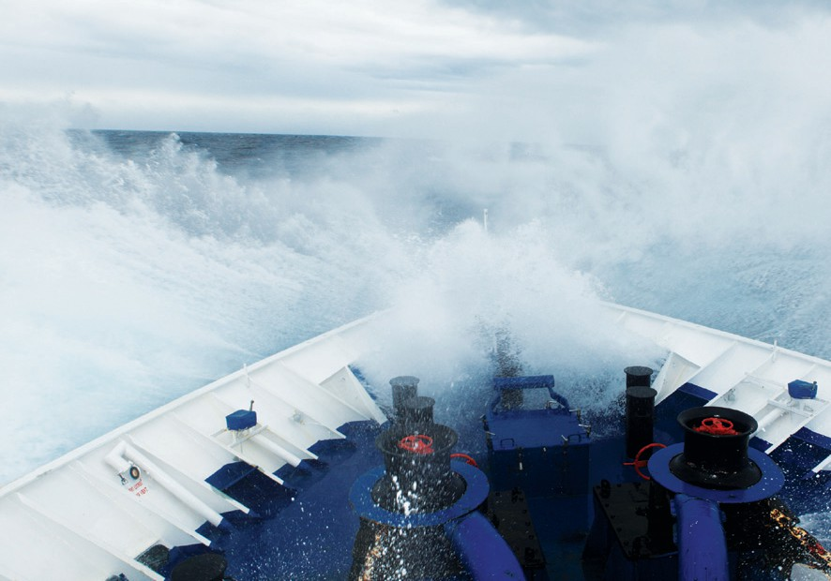

# C o n t e n t s

|  |  |
| --- | --- |
| **Executive summary** | **3** |
| **Introduction** | **4** |
| **Cargo damage in Heavy Weather** | **5** |
| **Cargo casualties** | **7** |
| **Container vessels** | **7** |
| **Bulk vessels** | **8** |
| **Hull damage in Heavy Weather** | **9** |
| **Hull damages** | **11** |
| **Cases in port** | **11** |
| **Cases at sea** | **11** |
| **Parametric rolling** | **12** |
| **Cargo hatch cover and doors** | **14** |
| **Weather routing** | **14** |
| **Interactive Root Cause Analysis cases** | **15** |
| **Heavy Weather caused containers to fall overboard** | **15** |
| **Cargo shifted in Heavy Weather** | **16** |
| **Prevention** | **17** |
| **Conclusion** | **20** |
| **Loss Prevention** | **21** |

**Executive summary**

## Factors for consideration

🞂​ Weather and sea conditions

🞂​ Condition of cargo securing equipment

🞂​ Condition of container tiers or cargo holds

🞂​ Condition of hatch covers

🞂​ Vessel speed

🞂​ Considering heavy weather while cargo planning

## Recurring issues

🞂​ Leaking hatch covers

🞂​ Lost containers

🞂​ Sailing in heavy weather

=> 9- Beaufort

🞂​ Not avoiding heavy weather

🞂​ Excessive speed in heavy weather

🞂​ Incorrectly stowed containers

🞂​ Defective container structure

🞂​ Excessive transverse metacentric height values

## Concerns

🞂​ Not using weather routing

🞂​ Parametric rolling

🞂​ Insufficiently experienced crews

🞂​ Crew ignoring company procedures

🞂​ Cargo securing equipment in poor condition

🞂​ Non-standard securing equipment

🞂​ Incorrectly declared cargo

## Preventive measures

|  |  |  |  |
| --- | --- | --- | --- |
| 🞂 | Weather routing should be used to |  | other openings to compartments |
|  | avoid adverse weather |  | and cargo holds |
| 🞂 | In heavy weather, adjust course and | 🞂 | Be aware of the risks of parametric |
|  | speed to ease the vessel’s motion |  | rolling |
| 🞂  🞂 | Train and address heavy weather issues (stowage and ship handling) during seminars and in ship handling simulators  Distributing circular letters to ves- sels, ensuring that crews are aware  of the problems with heavy weather |  |  |

🞂​ Implementing checklists, which ensure that cargoes are secured properly before sailing

🞂​ Implementing checklists, which ensure that openings and hatches on deck are secured properly before sailing

🞂​ Keep detailed records of mainte- nance, inspections and tests, com- pleted both by the crew and third parties regarding hatch covers and

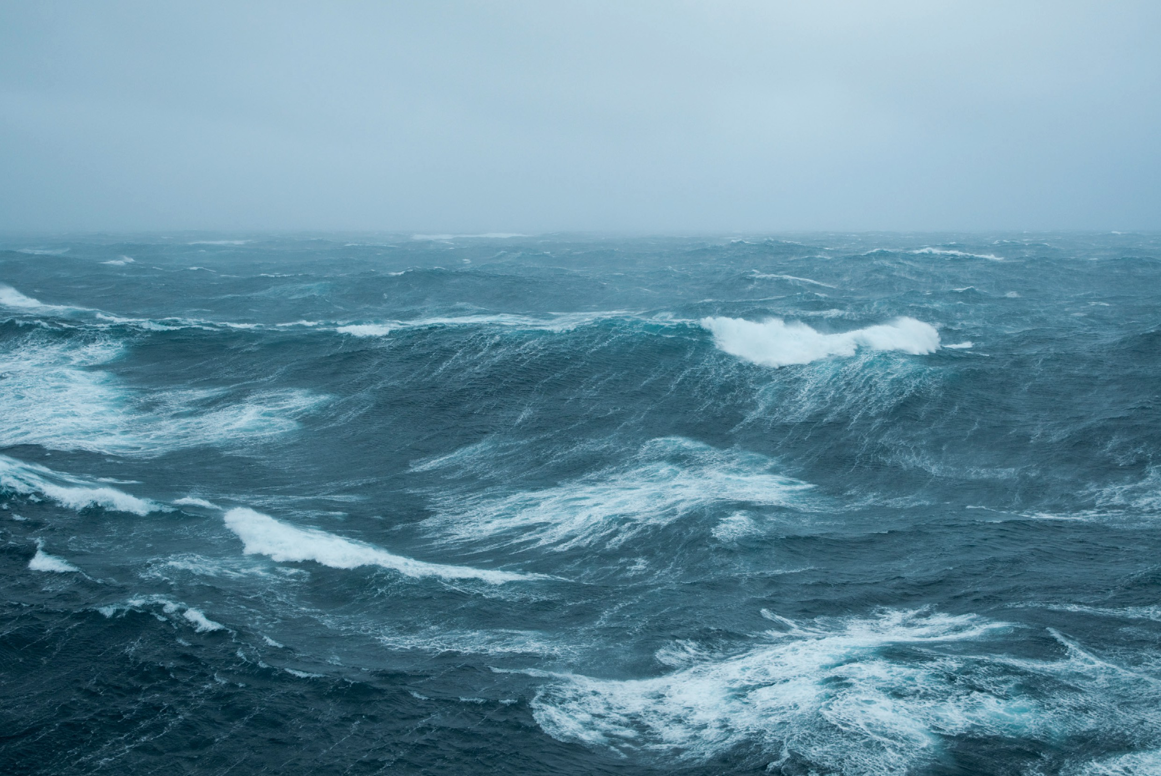

**3** [**www.swedishclub.com**](http://www.swedishclub.com/)

**Introduction**

Heavy weather does not only cause typical P&I claims such as damage to cargo or loss of cargo overboard. Heavy weather also causes H&M claims, which can include structural damage to the vessel or, damage to machinery and equipment etc.

A large proportion of cases where containers are lost at sea occur in heavy weather. The questions are:

🞂​ Why did the vessel sail through the heavy weather?

🞂​ Could the vessel have navigated around the heavy weather?

🞂​ Did the vessel use weather routing or not?

🞂​ Did the crew slow down or alter course to avoid the impact of large waves or high winds?

🞂​ Was the cargo correctly secured?

Casualties have been recorded when vessels are in port and a tsunami or hurricane hits. If the vessel receives information about a tsunami, hurricane or other severe weather heading for the port it is likely that the vessel is safer at sea than in port.

Today there are usually warnings about the development of a hurricane or other serious weather phenomenon.This information is usually available many days before the weather arrives. The key is how this information is being used and what preventive measures are being taken.

**Statistics 2005-2013**

This study is based on Bulker/Dry Cargo vessels, Container vessels, RoRo vessels and Tankers. This is because these vessel types cover more than 94% of

all insured vessels.

## All claims >USD 0

**Cargo claims, average cost** USD 54,000 (above deductible) **No of claims:** 179

**Hull and Machinery claims, average cost**

USD 118,000 (above deductible) No of claims: 130

**Graph No 1 - Beaufort scale Specifications and equivalent speeds**

|  |  |  |  |  |  |  |  |  |  |
| --- | --- | --- | --- | --- | --- | --- | --- | --- | --- |
| **Beaufort wind scale** | **Mean Wind Speed** | | **Limits of wind speed** | | **Wind descriptive terms** | **Probable wave height in metres** | **Probable maximum wave height in metres** | **Sea state** | **Sea descriptive terms** |
| **Knots** | **ms-1** | **Knots** | **ms-1** |
| 0 | 0 | 0 | <1 | <1 | Calm | - | - | 0 | Calm (glassy) |
| 1 | 2 | 1 | 1–3 | 1–2 | Light air | 0.1 | 0.1 | 1 | Calm (rippled) |
| 2 | 5 | 3 | 4–6 | 2–3 | Light breeze | 0.2 | 0.3 | 2 | Smooth (wave- lets) |
| 3 | 9 | 5 | 7–10 | 4–5 | Gentle breeze | 0.6 | 1.0 | 3 | Slight |
| 4 | 13 | 7 | 11–16 | 6–8 | Moderate breeze | 1.0 | 1.5 | 3–4 | Slight–Moderate |
| 5 | 19 | 10 | 17–21 | 9–11 | Fresh breeze | 2.0 | 2.5 | 4 | Moderate |
| 6 | 24 | 12 | 22–27 | 11–14 | Strong breeze | 3.0 | 4.0 | 5 | Rough |
| 7 | 30 | 15 | 28–33 | 14-17 | Near gale | 4.0 | 5.5 | 5–6 | Rough–Very rough |
| 8 | 37 | 19 | 34–40 | 17-21 | Gale | 5.5 | 7.5 | 6–7 | Very rough– High |
| 9 | 44 | 23 | 41–47 | 21-24 | Severe gale | 7.0 | 10.0 | 7 | High |
| 10 | 52 | 27 | 48–55 | 25-28 | Storm | 9.0 | 12.5 | 8 | Very High |
| 11 | 60 | 31 | 56–63 | 29-32 | Violent storm | 11.5 | 16.0 | 8 | Very High |
| 12 | - | - | 64+ | 33+ | Hurricane | 14+ | - | 9 | Phenomenal |

# Cargo damage in Heavy Weather

We have chosen to focus on cargo damage because it is the most com- mon claim for vessels encountering heavy weather. There are other P&I claims where heavy weather has been a contributory factor, like personal in- juries, man overboard and total losses, but these numbers are few. The most common factors for claims occurring

include the crew not managing to avoid the heavy weather, not slowing down or altering course to avoid large waves pounding the vessel.

Wet damage is mainly attributed to leaking cargo hatches. There are a number of cases when the deck has

been completely covered with water as the vessel did not slow down or alter course before big waves hit the vessel, covering the entire deck and hatches with seawater. If cargo hatches or other openings are not secured properly or in poor condition this will cause wet dam- age to the cargo.

The most common damage caused to cargo when encountering heavy weather is physical damage followed by wet damage and cargo lost over-

board. This emphasises the importance of weather routing, having a proper stowage plan and ensuring all cargo

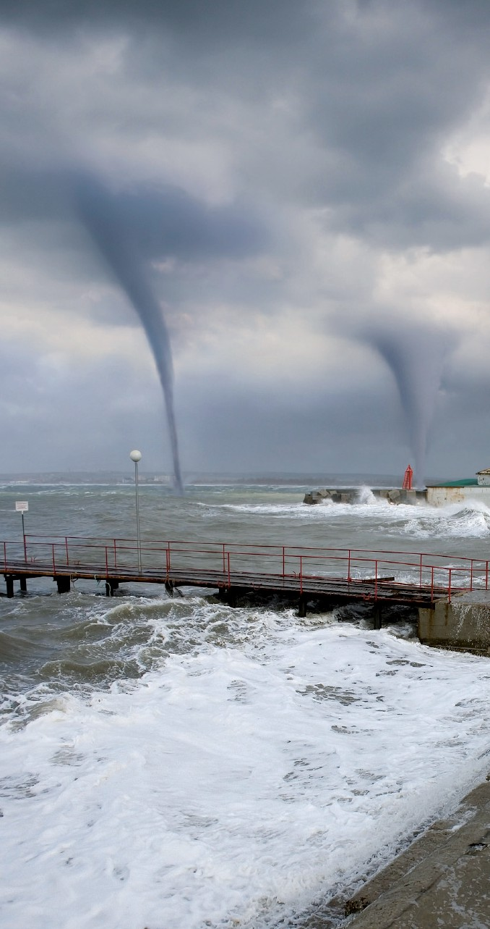is properly secured before the voyage commences. If the vessel sails through heavy weather without the cargo being properly secured it doesn’t matter if the vessel slows down or alters course, damage is likely to happen. Heavy movement of the vessel will break

the cargo lashings if the cargo is not secured correctly.

Looking at all cargo claims it is not surprising that most occur on Con- tainer vessels. This is due to the fact that cargo stowed on deck is obviously more susceptible to damage from heavy winds and large waves.

**Graph 2**

**2005-2013 Average cost Cargo: USD 54,000 (above deductible) No of claims: 179**

|  |  |
| --- | --- |
| **Vessel type** | **Average Claim** |
| Bulker/Dry Cargo | USD 44,000 |
| Container | USD 57,000 |
| Other | USD 0 |
| RoRo | USD 61,000 |
| Tanker | USD 1,800 |

**Graph 3. Number of claims per type Graph 4. Cost of claim type**

5% 2%

20%

65%

10%

Physical damage Wet damage Lost overboard Other

45%

39%

14%

**Graph 5. Number of claims per cargo type**

**Graph 6. Cost of claims per cargo type**

2% 2% 4%

3%

4%

5%

%

7%

6%

7

8%

52%

Container unitised RoRo

Container dry bulk

1%

0% 1% 1%

2%

13%

%

%

19%

Steel products

General 2

2

Dry bulk Container reefer Machinery Vehicles Bagged bulk Other

57%

The reason why RoRo vessels are more exposed to heavy weather claims appears to be that it is not very forgiv- ing to sail through heavy weather if the cargo is not secured and stowed cor- rectly. This will not only lead to cargo damage but also structural damage as can be seen on page 12 under H&M casualties.

Waves and wind can wash containers and trailers overboard or cause physical damage. If the vessel is moving a lot in

the sea this can cause containers to fall overboard as the IRCA (Interactive Root Cause Analysis) case on page 16 shows. It is essential that all cargo is secured as per the cargo-securing manual, that the cargo computer is correctly calibrated, that the cargo inside the container is correctly declared. We do acknowl- edge however that it is difficult for the owner to know exactly what is inside

all containers onboard. The fact is that the problem with incorrectly declared

containers is very costly for the ship- ping industry.

The problem with not securing and loading cargo properly is shown in the IRCA case on page 17.

Why there are almost no casualties on tanker vessels is attributed to that they do not have big cargo hatches as on bulker vessels or cargo that will be damaged if the vessel is moving a lot, which is a risk on Container and RoRo vessels.

**Graph 7. P**&**I: Heavy weather cargo damage**

**Graph 8. P**&**I: Distribution of claims**

70% 50%

60%

50%

40%

30%

20%

10%

40%

30%

20%

10%

0%

Bulker/Dry Container RoRo Tanker Other

0%

Bulker/Dry Container RoRo Tanker Other

Club entry  No of claims  Claims cost  Frequency  Cost

**Cargo casualties**

**The cases below happened on Bulker, Container or RoRo vessels.**

**Container vessels**

When a container vessel sails through heavy weather the container stacks will be under a lot of stress and damage to the hull or cargo are not uncommon.

There have been a number of cases where the weight of the cargo in the containers was incorrectly declared, causing entire container stacks to collapse, damaging the

vessel structure, the cargo in the container being damaged or containers falling overboard.

The above emphasizes the importance of using weather routing. This, combined with ignoring the cargo securing manual and incorrectly declared cargo can be dangerous and costly.

It is not uncommon that cargo on flat rack containers shifts when vessels pitch and roll heavily. It is important to ensure that the cargo is always secured correctly especially if heavy weather is anticipated.

The wide beam of many container vessels usually results in large GM (metacentric heights) values. In some cases where the vessel is partly loaded, the GMs appear to have been excessive. This can become very problematic if the vessel is caught in heavy weather causing cargo-securing arrange- ments to break and containers to fall overboard. To avoid heavy weather it is essential to monitor the weather during the entire voyage. If the vessel cannot avoid heavy weather it is essential to take proper actions such as reducing speed and altering course if needed.

## Cases

🞂​ Containers were secured as per the cargo-securing manual. The vessel sailed through heavy weather, with large waves. This caused the vessel to roll more than 30 degrees. Eleven containers were lost overboard and twelve were damaged. The vessel had received reports about the heavy weather in the area. The vessel’s average speed was about 15 knots.

🞂​ A vessel experienced heavy weather, Beaufort 10, lost a couple of containers overboard when the vessel listed heavily from large waves.

🞂​ A vessel lost eight containers overboard when sailing through heavy weather Beaufort 9. It was also revealed that the weight of the cargo in some of the containers had been incorrectly declared and that some containers were not secured as per the cargo-securing manual. The investigation revealed that stack weights had been grossly overweight and that Charterers had not followed the vessel’s Securing Manual.

🞂​ A vessel encountered stormy weather at Beaufort 9 and large waves. The vessel was rolling and pitching heavily and seawater covered the deck. The vessel altered course, reduced speed, in an attempt to reduce the impact of the waves. Two hydraulic drill crawlers on flat racks shifted when the vessel rolled 30 degrees and fell onto containers below.

🞂​ A vessel was at anchor when a typhoon hit the area. Large components on a flat rack container fell down on top

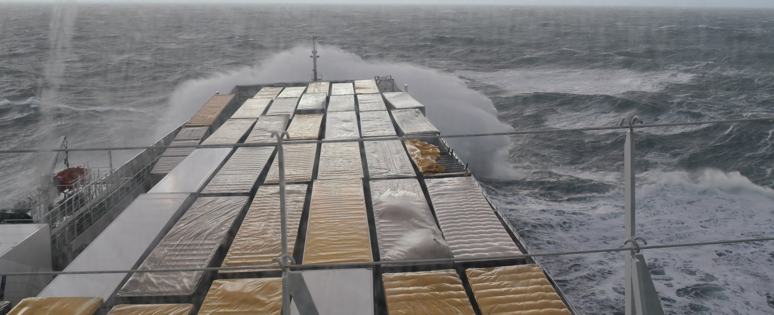of another container when the vessel rolled heavily. The components and the other container were damaged.

**Bulker vessels**

When a Bulk vessel encounters heavy weather the most common immediate cause of cargo damage is leaking cargo hatches as we can see from the cases below. To avoid the un- desirable consequences of heavy weather it is essential that weather routing be used. The issue of leaking cargo hatches has been dealt with in our **Wet Damage to Cargo** publication, but it is also mentioned again on page 14.

## Cases

🞂​ A vessel had passed a water hose test. When loading was complete the cargo hatch covers had been sealed with tape. During the voyage the vessel encountered heavy weather, Beaufort 10 and large waves. When the cargo was discharged it was evident that the cargo had been damaged by saltwater. An ultrasonic test was completed and it showed that the cargo hatch covers were leaking through the cross joints.

🞂​ A vessel had loaded raw cane sugar in Africa for discharge in Europe. During the voyage to Europe the vessel expe- rienced heavy weather, Beaufort 10 and the cargo was damaged because of leaking cargo hatch covers.

🞂​ A vessel sailed through heavy weather with large waves, which broke the seals on the cargo hatch covers. In the discharge port it was discovered that the cargo had suffered damage from salt water. The damage was attributed to leaking cargo hatch covers.

🞂​ A vessel encountered heavy weather during the voyage and the cargo was damaged by salt water, caused by leaking cargo hatch covers.

🞂​ A vessel experienced heavy weather, Beaufort 10, causing the vessel to roll and pitch heavily. Tapes for the cargo hatches were damaged and the cargo was damaged because of leaking cargo hatch covers.

🞂​ A vessel encountered heavy weather in the pacific, Beaufort 9 and large waves at 9 metres, causing a lot of rolling and pitching. There was some dam- age to the cargo, which was attributed to a leaking cargo hatch cover.

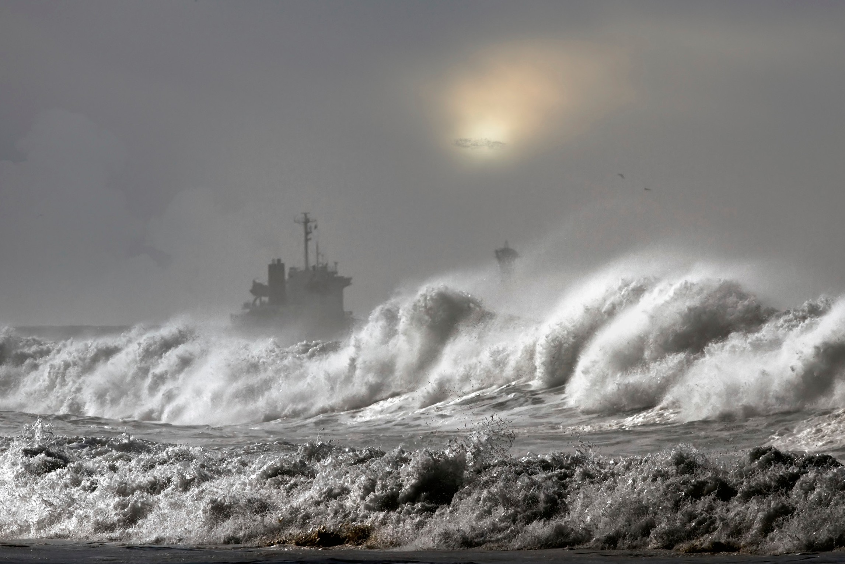

# Hull damage in Heavy Weather

The reason why hull damage occurs when vessels sail in heavy weather is the same as the reason for cargo damage. If crews do not slow down or alter course to avoid large waves, there is risk of the hull damage.

If the vessel is not able to avoid the heavy weather it is essential that all openings and hatches are secured properly. Poorly secured cargo can cause hull damage if it comes loose.

If the cargo is not properly secured it doesn’t matter if the vessel slows down or alters course, as the cargo lashings can break because of the vessel’s heavy movement.

There are cases when the bosun store or other compart- ments have been filled with water, causing damage to elec- trical equipment, which can cause further failure to mooring winches, anchor winches or even the bow thrusters.

**Graph 9.**

**2005-2013 Average Cost Hull:**

**USD 118,000**

**(above deductible) No of claims: 130**

|  |  |
| --- | --- |
| **Vessel type** | **Average Claim** |
| Bulker/Dry Cargo | USD 133,000 |
| Container | USD 102,000 |
| Other | USD 211,000 |
| RoRo | USD 152,000 |
| Tanker | USD 97,000 |

**Graph 11.**

**Frequency of claims per vessel type**

7%

3%

27%

15%

48%

Bulker Container RoRo Tanker Other

**Graph 10.**

**Geographical location of the casualty**

5%



2% 19%

3%

5%

14%

Atlantic Ocean, North,19% Pacific Ocean, North, 14% Atlantic Ocean, South, 9% Bay of Biscay, 8%

South China Sea, 7% Indian Ocean, 6%

Arabian Sea, 2% East China Sea, 2% Bay of Bengal, 2%

Mississippi/Missouri, 2 %

Baltic Sea, 2%

Inland water − Other, 2%

6%

9%

6%

7% 8%

Mediterranean Sea, 6%

North Sea, 5%

Pacific Ocean, South, 3% English Channel, 2%

Yellow Sea, 2%

Irish Sea, 2%

Other, 5%

It is not surprising that 33% of all H&M heavy weather claims happen in the Atlantic and Pacific oceans. Of these claims 48% are for Container vessels, 27% for Bulker vessels and 15% for RoRo vessels.

This is similar to P&I as Bulker/Dry cargo vessels and Container vessels have most claims. The highest risk is actually for Other vessels, which mostly consists of heavy lift vessels followed by Container and RoRo vessels. This is better displayed in Graph 13. Both Container and RoRo vessels usually travel at higher speeds then Bulker and Tanker vessels as an overweight container can cause damage due to container tiers collapsing or the RoRo causes damage in the cargo hold. It is obvious that bulk cargo, dry or wet, will not cause damage to the hull. Still, Bulker and Tanker vessels need to slow down and alter course when they

**Graph 12. H**&**M: Heavy weather**

50%

40%

30%

20%

10%

0%

Bulker/Dry Container RoRo Tanker Other

encounter heavy weather. If a vessel is maintaining 10 knots and

large waves hit the bow the vessel can suffer damage either to

Club entry

No of claims  Claims cost

the bow section, or if water enters a compartment this can cause damage to equipment which could cause a blackout.

As Graph 13 shows, the highest risk for hull damage is for Other vessels, which in this case mostly consists of Heavy lift vessels, followed by Container and RoRo vessels. The costly claims for RoRo and Heavy lift vessels can be attributed to when securing arrangements for the cargo break resulting in damage to the vessel as the cargo usually consists of very large compo- nents. This also shows that cargo damage can lead to damage

to hull and equipment. The reason why there are fewer heavy weather claims on tankers cannot be statistically confirmed, but it might be because tankers have higher demands from their charterers and stricter requirements.

**Graph 13. H**&**M: Distribution of claims**

40%

30%

20%

10%

0%

Bulker/Dry Container RoRo Tanker Other

Frequency  Cost

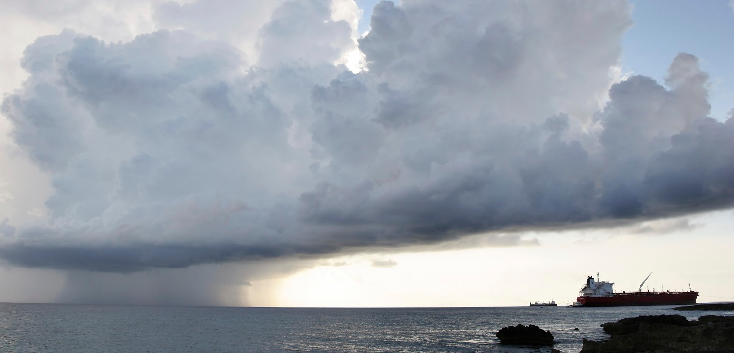

**Hull damages**

The cases below are examples of different claims happening on different vessel types. The cases are separated between vessels being in port or at sea. It is usually better to be at sea than in port if severe heavy weather is approaching, such as hurricanes or tsunamis.

## Cases in port

Below we can see that damage can be caused if the vessel stays in port when heavy weather is approaching. There can be damage to own vessels, but also to other vessels and facilities. The risk of running aground also increase.

🞂​ The moorings broke when the Bulker vessel was alongside and a hurricane hit the port. The vessel started to drift and hit other vessels.

🞂​ Damage to the Container vessel and shore cranes after a tsunami hit the port. Shore cranes were left in a horizontal position and when the tsunami hit the port it moved the vessel, causing damage to the cranes. The cargo holds of the vessel were also punctured and flooded.

🞂​ A hurricane struck the Bulker vessel when it was alongside in port, causing damage to the rudder and steering gear.

🞂​ A storm hit the port when the RoRo vessel was alongside, moorings broke and the vessel drifted aground, but before this the vessel collided with a couple of other vessels.

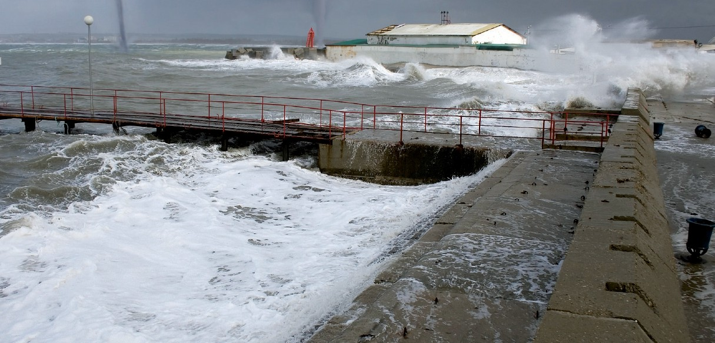🞂​ Departure was cancelled due to really strong winds, Beaufort 10. During the night the wind increased and eight mooring lines broke. Even a shore bollard was pulled into the water. There was also some swell in combination with the strong wind, causing the Container vessel to move a lot. Three tugs were requested to assist the vessel until it was possible for the vessel to depart in the afternoon.

## Cases at sea

If the vessel has not avoided the heavy weather this can lead to damage to the structure and equipment.

🞂​ An HSC vessel encountered worse weather than anticipated and suffered damage to the bow and composite structure.

🞂​ A Container vessel sailed into very heavy weather, Beaufort 11, waves about 8 metres. There was some damage to the forecastle, main deck and the wave breaker collapsed. The chain locker and thruster room were flooded as were two of the cargo holds.

🞂​ Waves hit the stern of the Container vessel, causing damage to the stern tube bush, the propeller and the tail shaft had to be removed.

🞂​ A heavy lift vessel sailed through heavy weather with waves of about 6 metres, causing the vessel to roll 25º. This caused the cargo to shift and damage the structure in the cargo hold.

🞂​ A tropical storm developed in the area the vessel was sailing. The vessel was heading into port but it was closed at the time. The master decided that the vessel should drift and wait out the storm. It was a heavy lift vessel and the cargo shifted causing damage to the structure.

🞂​ A Bulker vessel was in a storm and suddenly the radar mast collapsed. There was a large swell and winds of Beaufort 10, the vessel was pitching and rolling heavily.

🞂​ During the Container vessel’s passage it experienced 5 metre waves. Suddenly some very large waves hit the vessel, causing damage to the deck plating and structure.

# Parametric rolling

**We would like to thank Mikael Huss from Wallenius Marine for writing this section about Parametric rolling.**

Vessels optimized to carry large volumes of cargo, such as car carriers (PCTC) and container vessels, have achieved dramatic developments in higher efficiency, measured as fuel consumption per cargo volume and distance. While container vessels have increased significantly in overall size, car carriers’ length, breadth and draught have so far been restricted by various constraints from routes and ports, with cargo volumes mainly increasing with more decks and increased height. Still, a 200m PCTC from 2010 can carry about 40% more cars than a 200m PCTC from 1980, with the same main dimensions.

This increase of cargo space and transport efficiency could not have been achieved without a parallel development of sophisticated hulls with very high form stability, combined with slender lines and low resistance. Similar hull forms can now

be found on large passenger cruise vessels with their special requirements on volumes and heights.

These new hull forms show a significantly larger vari-ation in stability during a wave passage compared to more tradi- tional forms. This is not a problem per se because the average stability in waves is generally higher than in calm water. How- ever, in certain conditions this variation might increase the risk of heavy roll or heel amplitudes.

The effect of stability variations in waves has been an expanding research area in recent decades. IMO issued its first circular, MSC/Circ.707, with **‘Guidance to the Master for avoiding dangerous situations in following and quartering seas’ in 1995**, and after some reported incidents in head sea it was replaced in 2007 by MSC.1/Circ.1228 **‘Revised guidance to the Master for avoiding dangerous situations in adverse weather and sea conditions’**.

## What is parametric roll?

Ordinary (synchronous) roll motions in waves can be described as a state of dynamic equilibrium between internal moments from inertia, damping and stability and external moments from the waves.

Like all other phenomena induced by irregular seas becomes rolling a random process where the characteristics need to be described by statistical distributions. The roll response is very

sensitive to the period of excitation so that only the part of the encountering irregular wave energy spectrum that coincides with the natural period of roll will be effective.

The roll amplitudes are therefore directly dependent on the wave height, length and direction of encounter while the roll period is almost entirely governed by the initial stability *GM* and the radius of inertia *r*.

The stability variation is caused by the waves but there need not be any direct roll moments from waves, so parametric roll can, and will actually most likely, appear in head or following seas when there is very little direct roll excitation from waves. This makes the phenomenon almost impossible to predict on beforehand by using your senses or experience.

## What makes parametric roll appear – and disappear?

The following three conditions are required for parametric roll to develop:

🞂​ **Large relative variation of stability**, which can be caused by a combination of:

* a hull form with large flare around the water line and large breadth/draught ratio,
* relatively low initial stability in the loading condition,
* waves as long as the vessel length, (most critical at 80% *L* but at least in the range 50-150% *L range*),
* sufficiently large wave amplitudes.

🞂​ **Resonance** between stability variation and vessel’s natural period of roll requiring:

* a wave encounter period half (or less critical, equal to) the roll period,
* regularity in waves so that resonant periods are kept for a sufficient number of cycles,
* a critical phase lag between rolling and stability variation

🞂​ **Low hydrodynamic roll damping**, which is generally the case for most vessels, but typically exaggerated by:

- a slender hull with large bilge radius, small bilge keels and low speed.

The risk of a severe outcome from parametric roll is the combined effect from these three conditions; if resonance is perfect and damping low there need not be a very large variation in stability and if the variation is large, there need not be perfect resonance, etc. Figure 1 shows the relationvessel between the three prerequisites in regular waves where criticality is described as a combination of roll growth ratio and roll amplitudes.

A crew that is prepared for parametric roll may also enforce rapid changes in speed and course that will change conditions and stop further resonance.

## Two examples

Figure 2 and Figure 3 show two examples of parametric roll as measured onboard vessels in service. The first example in Figure 2 shows a case in following sea with moderate waves where there was hardly any pitch or roll motions before

the severe rolling appeared. The second case is from rather rough head sea. Both cases clearly show the perfect 2:1 resonance between the rapidly increasing roll motions and pitch motions that are directly governed by the encountering waves. The roll starts to diminish as soon as the regularity is disturbed, either by irregularities in the wave sequence or by action onboard.

**What can be done to reduce the risk?** Mitigating risk from parametric roll currently includes a chain of activities:

🞂​ Design optimization based on extensive numerical simulations to ascertain vessels hull forms that are sufficiently robust for their intended service

🞂​ Education of all officers on wave stability in general, on the specific characteristics and service experience of

different generations of vessels and on decision support systems onboard

🞂​ Decision support systems including:

- route planning and optimization based on forecasted weather conditions, among other criteria, assessment of risk for parametric roll along the route

🞂​ real-time assessment of sea conditions at, with warnings and advice on possible actions for avoiding high

risk situations,

🞂​ Regular procedures for following up and analyzing

all events that may contribute to increased knowledge and awareness.

1.5

Critical

area

Critical

area

1.0

0.5

Different level

of damping

0.5 1.0

1.5

2.0

GM Variation Period / Natural Roll period

GM Variation Amplitude / GM0

***Figure 1.*** *Illustration of critical areas where parametric roll may appear. The diagram is based on numerical simulations in regular waves. The most critical area is where the stability variation has a period of half the roll period. Long stability variation periods approaches what is generally known as ‘loss of stability’*

30

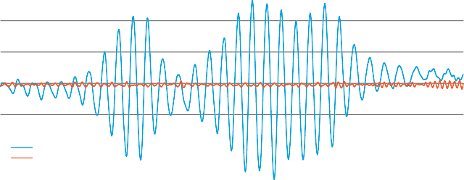

Roll

Pitch

20

10

Roll, Pitch [deg]

0

-10

-20

-30

0 60 120 180 240 300 360 420 480 540 600 660 720 780 840 900

time [s]

***Figure 2.*** *Parametric roll in following sea. Speed 10kn, GM 1.2m, significant wave height 4.1m, Natural period of roll 28s, encounter wave spectrum peak period 14.3s*

20

Roll

Pitch

10

Roll, Pitch [deg]

0

-10

-20

0 60 120 180 240 300 360 420 480 540 600

time [s]

***Figure 3.*** *Parametric roll in head sea. Speed 12kn, GM 2.3m, significant wave height 5-6m, Natural period of roll 21s, encounter wave spectrum peak period 8-11s*

**Cargo hatch covers and doors**

When vessels sail in heavy weather and have not reduced speed or altered course to minimize the impact of the heavy weather it is not uncommon for the deck and cargo hatch covers to

be fully immersed in seawater. This can lead to cargo claims if the cargo hatch cover joints, seals and coamings, are in poor condition and seawater enter the cargo hold.

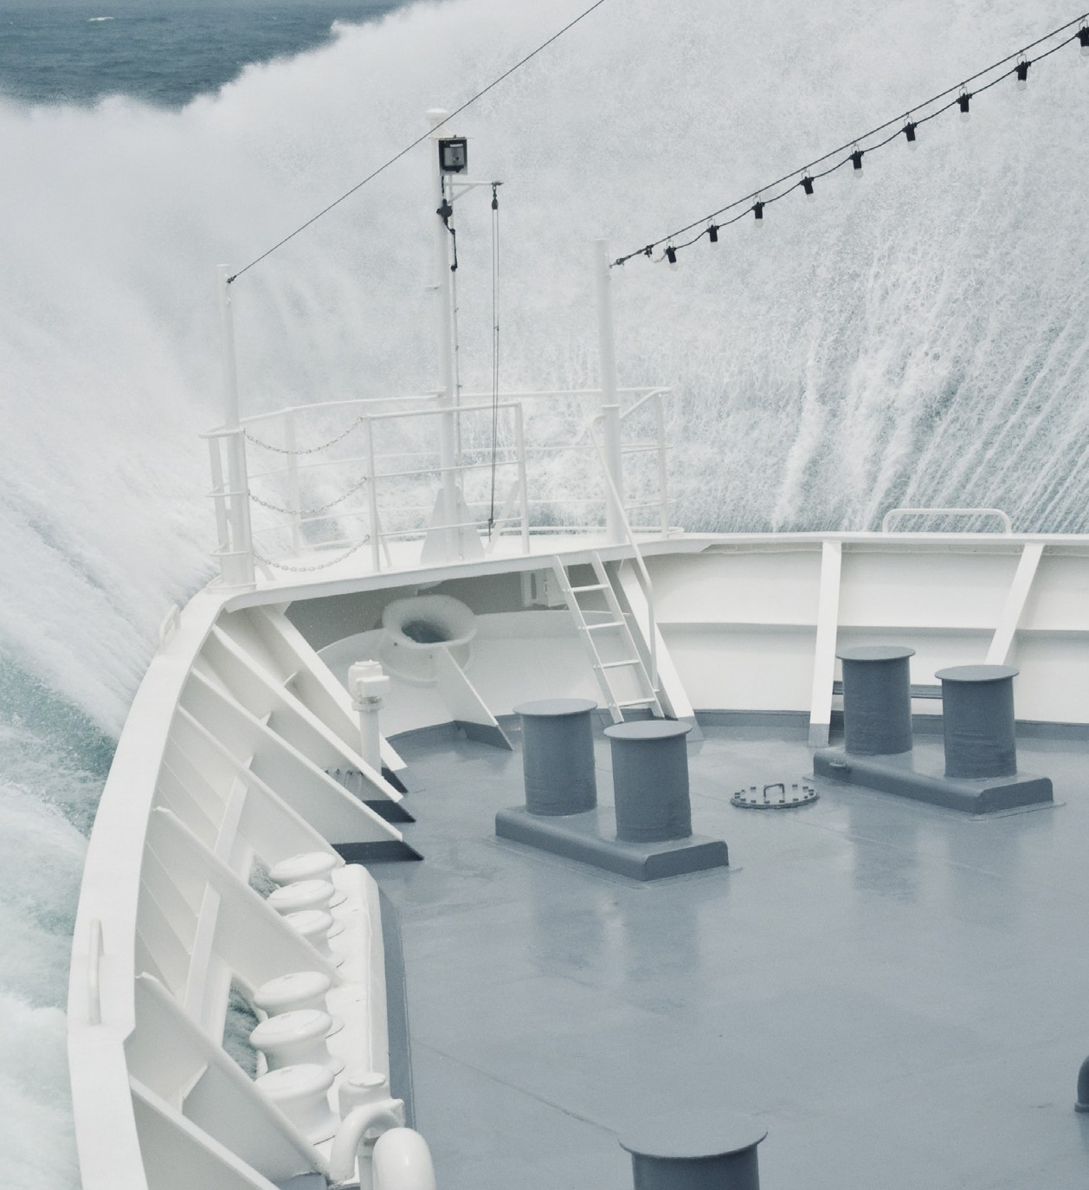Poor condition of cargo hatch covers is often due to poor maintenance. Leaks can also be caused because the cargo hatches are battened

down incorrectly. Before sailing it is essential that the crew ensure that all cargo hatches and other openings are secured properly, this is imperative if heavy weather is anticipated.

There are numerous cases where compart- ments were filled with seawater because hatches or doors were not secured correctly. This can cause damage to electrical equipment within these compart- ments. In some cases the seawater disabled anchors and mooring winches. This results

in the vessel requiring

extra tugs to enter the

port and subsequent repairs before being able to resume trade.

Another issue is if a cargo hatch is secured too tightly, which could damage the seal. If the gasket is too compressed it will be counterproductive. It is essential that the correct pressure is applied. The cargo hatch should be secured as per the manufacturer’s instructions.

It is essential that cargo hatch covers are inspected and tested at regular intervals to ensure that the watertight integ- rity is maintained and that the vessel is in a cargo-worthy and seaworthy condition.

The most reliable test for ensuring that the cargo hatches are in good condition is the ultrasonic test.

The ultrasonic device is designed for this purpose and can pinpoint the leak and if compression of the gasket is sufficient.

It is important that records are kept about what maintenance and service has been completed in the PMS (Planned Main- tenance System). It is also important that the SMS (Safety Management System) addresses how maintenance is carried out and what areas need to be inspected and tested.

**Weather routing**

In today’s market customers demand that their cargo arrives on

time. Just-in-time logis- tics has forced shipown- ers to ensure their vessels keep to schedules.

Running into heavy weather does not just mean that the ETA (Estimated Time of Arrival) is not met but also that the bunker consumption will be higher to reach the destined port of call. To be able to prevent this it is important to plan the most efficient route, which weather routing can provide.

The purpose of

weather routing is to avoid heavy weather and ensure that the vessel arrives safely at the discharge port. It is essential that the crew

are aware of the weather for the upcoming voyage. This is best achieved by professional weather routing, which provides weather forecasts for the intended route and recommenda- tions on the ocean crossing.

To be able to receive weather routing recommendations, vessels are equipped with satellite communication, and some also have constant internet connection through satellites.

Weather routing not only provides vessels with the option of how to avoid heavy weather, but also ensures that vessels get new and updated ETA to the discharge port.

This helps crews onboard the vessels, personnel in the office and cargo owners to plan accordingly.

There are multiple weather routing providers, providing a range of services. It is essential that managers chose a provider that can deliver the required service.

# Interactive Root Cause Analysis cases

**Heavy weather caused containers**

|  |  |  |
| --- | --- | --- |
| **WHAT? Containerslost overboard in heavy**  **weather** | | |
|  | |  |
| **WHY?** | **Vessel lost some containers when it rolled heavily due to heading into severe weather.** | |
|  | |  |
| **WHY?** | **Containers were not lashed according to the cargo securing manual, causing lateral and vertical movement of the top**  **containers.** | |
|  | |  |
| **WHY?** | **Because of the different height of containers, which created an uneven stowage block, it was difficult to fit bridge fittings and twistlocks.** | |
|  | |  |
| **WHY?** | **The master had informed the char- terer that the cargo plan had too heavy containers in the top stacks and asked for the containers to be stowed further down. The next day it was discovered that heavy containers had been loaded on the top stacks. The existing lashings**  **could not stop the containers moving, and some were more than twice the permitted weight for the specific stacks.** | |
|  | |  |
| **WHY?** | **The charterer ignored the weight limits and the master’s request not to load any heavy containers on the top stacks.** | |
|  | |  |
| **CONSEQUENCES**  🞂​ **Containers lost overboard and damage to vessel.** | | |

**to fall overboard**

**A container vessel left a Spanish port heading for a port in Portugal. After entering the Atlantic the vessel altered to a NE course and faced strong NW winds and a NW 3 metre swell, which hit the vessel’s port side causing the vessel to roll heavily. The vessel altered back to a NW course to reduce the roll.**

However, the wind force and swell increased, causing the vessel to continue to roll heavily and it encountered a NNW swell of about 5 metres with a force 6 NNW wind. This led to the loss of some containers.

The containers had been secured by the crew and were not secured as per the cargo securing manual.

The lost containers were much heavier than the weight allowed in those stacks. The master had actually informed the charterer to only load empty containers in the top stacks. This was ignored by the charterer. The reason for this is unclear. The heavy containers were discovered by the vessel’s crew the day after departure. Because of the vessel’s heavy rolling and lack of sufficient bridge fittings and twistlocks, the existing lashing and turnbuckles broke and some containers fell overboard.

When the containers fell overboard they damaged the vessel’s railings and hatches.

The loss of the containers was likely caused by a combi- nation of circumstances such as excess weight in the top container, heavy rolling experienced by the vessel, insuf- ficient lashings and that the charterer had ignored the

master’s request.

Incorrectly declared cargo is a major concern in the container trade and unfortunately it is very difficult to prevent. There are container vessel operators who actually blacklist shippers who incorrectly declare cargo.

**Preventing it reoccurring**

🞂​ The containers should have been secured according to the cargo securing manual

🞂​ The company should review their cargo handling procedures to ensure that all cargo is secured correctly

🞂​ The company should inform the charterer that it is not acceptable to ignore the master’s requests. This is apparently not the first time that the charterer has done this and this is a major safety concern

🞂​ The company should consider weather routing as the severe weather did have an impact

**Cargo shifted in heavy weather**

**A vessel was carrying paper rolls on a voyage from Canada to Europe during winter in the North Atlantic. During the loading operation the stevedores left a lot of void space between the stacks. Cargo of different heights and width had also been stowed in the same stacks.**

|  |  |  |
| --- | --- | --- |
| **WHAT? Damage to cargo in severe weather** | | |
|  | |  |
| **WHY?** | **Vessel sailed in heavy weather and the master was unfamiliar with the anti- heeling system and had not received training about the system. He did not reduce speed or take any other mitigating factors into account before the cargo shifted and the stevedores had not secured the cargo correctly** | |
|  | |  |
| **WHY?** | **The crew did not request the stevedores to load the cargo correctly** | |
|  | |  |
| **WHY?** | **Stevedores had threatened to stop loading if the crew interfered** | |
|  | |  |
| **WHY?** | **The crew was not firm enough with the stevedores and were unfamiliar with how to deal with the situation and allowed the stevedores continue loading** | |
|  | |  |
| **WHY?** | **No clear guidelines from the office on how to deal with stevedores. The vessel did not carry out enough preventive measures before proceeding into adverse weather** | |
|  | |  |
| **CONSEQUENCES**  🞂​ **The cargo shift caused extensive damage to over 2000 rolls, which resulted in a claim. More than 60% of the cargo was damaged** | | |

The chief officer voiced his concern to the stevedores about the poor loading. The stevedores threatened to stop working and involve the union. This could potentially delay the vessel so the chief officer decided not to request the stevedores to reload the vessel. It has not been established why the chief officer did not realize that there was a substantial risk that the cargo would shift if it was not properly loaded and secured.

The vessel departed on a SW course at a speed of about 13 knots, visibility was limited. At the beginning of the journey the vessel was protected by islands, but when entering the North Atlantic the vessel encountered even more adverse weather with force 9-10 ENE winds, later dropping to force 6-8 ESE with rough seas of around 6m. During this time the vessel heeled heavily 12-15 times in excess of 30°, causing the paper rolls to shift due to not being properly stowed. The crew tried to secure the cargo by inflating and placing extra air cushions and rubber bags between the cargo rolls that had shifted,

but without much success. One AB was ordered to stay in the cargo hold and monitor the situation.

By taking at least some minimum proactive measures the crew could have tried to secure the cargo with air cushions and rubber bags. The anti-heeling system could have been started earlier and the GM lowered.

It is likely that there would have been less damage if the vessel had applied varying courses and reduced its speed to avoid the major heeling as soon as they encountered the severe weather.

Anti-heeling tanks were finally started by the chief officer,

side tanks filled and double bottom tanks emptied to lower the GM but it was too late. The vessel eventually altered course to avoid most of the adverse weather.

**Preventing it reoccurring**

🞂​ All officers working on this type of vessel have now received training about the anti-heeling system

🞂​ The company sent a memo to affected vessels where they stressed the crew’s obligation to monitor the cargo operation and to be firm with stevedores and stop loading if the stevedores do not comply

🞂​ The company needs to review its cargo handling procedures, because it is unacceptable to leave port with cargo not properly loaded and secured

🞂​ The company should review its procedures when dealing with severe weather

🞂​ The vessel should consider implementing weather routing because the vessel knew it was entering adverse weather as per the weather forecast

**Prevention**

When preparing a vessel for sea it is essential that it is loaded as per the cargo securing manual, which provides guidance on securing devices and arrangements, stowage and securing of non-standardised cargo, plus stowage and securing of containers.

To avoid excessive acceleration and forces, course and speed may need to be adjusted for the vessel’s motion in heavy seas. Early avoidance of heavy weather and adverse sea conditions is always recommended.

As we can see from the cases mentioned in this publication if the vessel had reduced its speed it is probable that there would not have been any damage. As always the crew has to secure the cargo properly before sailing, but if heavy weather is anticipated it is important that the crew double-check the securing arrangements before sailing. This can prevent costly claims.

Taking into account the actual stability conditions, it may be necessary to ballast or de-ballast the vessel, improving the behaviour and avoiding excessive acceleration.

During loading it is not unusual for the stowage plan to change. This gives little time to evaluate the changes. Another concern during loading is that stevedores secure containers with deteriorated lashing equipment. It is impor- tant that lashing equipment is in good condition and that equipment in poor condition is being removed to prevent it from being used.

If the tier structure collapses on a container vessel when sailing in heavy weather it can actually worsen the situation if the crew tries to re-lash the container stacks because the collapsed posts are becoming even more overloaded.

Also being aware and training officers about the mentioned risks with parametric rolling is imperative.

The best preventive measure any vessel can take against heavy weather damage is to slow down and to alter to a more favourable course.

**Preventive measures**

🞂​ Weather routing should be used to avoid adverse weather

🞂​ In heavy weather, adjust course and speed to ease the vessel's motion

🞂​ Train and address heavy weather issues (stowage and ship handling) during seminars and in ship handling simulators

🞂​ Distributing circular letters to vessels to ensure that the crew are aware of the problems with heavy weather

🞂​ Implementing checklists that ensure that cargo is secured properly before sailing

🞂​ Implementing checklists that ensure that openings and hatches on deck are secured properly before sailing

🞂​ Keep detailed records of maintenance, inspections and tests, completed both by the crew and third parties regarding hatch covers and other openings to compartments and cargo holds

🞂​ Be aware of the risks of parametric rolling

## Specific prevention for container vessels

🞂​ Weather routing should be used to avoid adverse weather

🞂​ In heavy weather, adjust course and speed to ease the vessel's motion

🞂​ Complete risk assessment for encountering heavy weather

🞂​ Check and verify that the lashing methods follow the requirements as outlined in the vessel's cargo securing manual

🞂​ The cargo securing manual should be applicable for the stowage arrangements and lashing equipment used, written in a language readily understood by the crew and other people employed for securing the cargo

🞂​ Lashing equipment and securing points must be maintained regularly and inspected for wear

🞂​ Have procedures in place for calibrating the loading computer

🞂​ Try to reduce the vessel's GM when not fully laden

🞂​ If possible, check that container seals are intact and that containers are secured correctly if the vessel is heading into heavy weather

🞂​ Do not mix high cube containers with standard height containers in stacks. This does not allow bridging pieces to be fitted between stacks

🞂​ Ensure that weights are declared and that maximum stack mass and height limits are not exceeded

🞂​ Keep detailed records of maintenance, inspections and tests completed both by the crew and third parties regarding hatch covers and other openings to compartments and cargo holds

🞂​ Be aware of the risks with parametric rolling

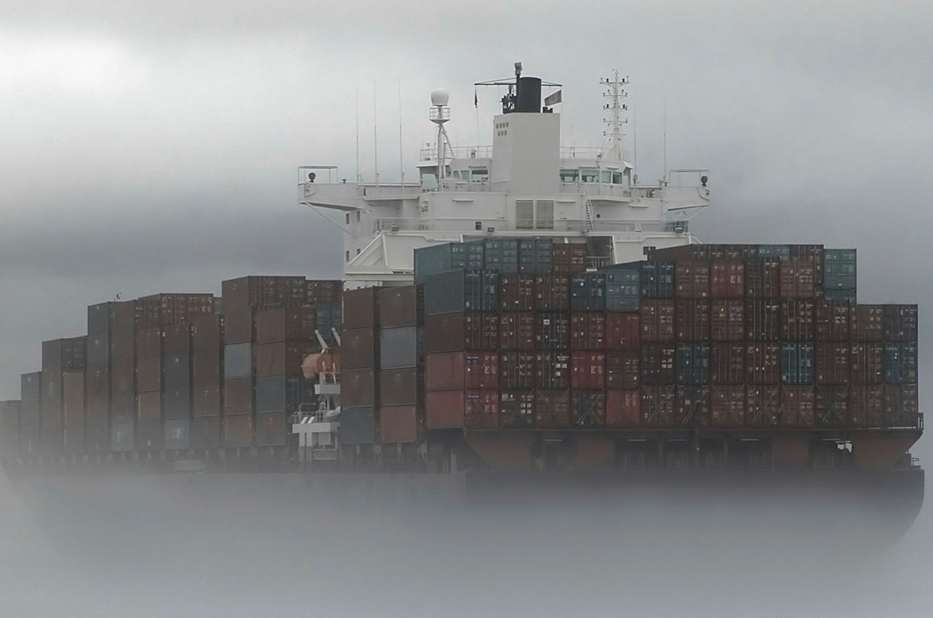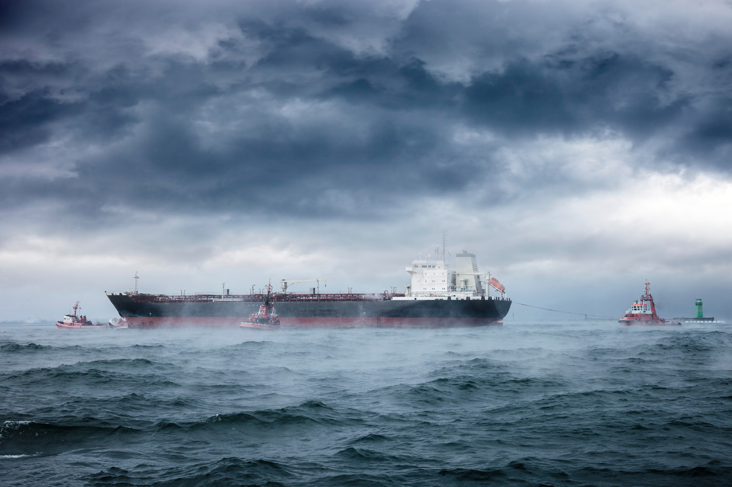

**Specific prevention for bulkers**

🞂​ Weather routing should be used to avoid adverse weather

🞂​ In heavy weather, adjust course and speed to ease the vessel's motion

🞂​ Train and address heavy weather issues (stowage and ship handling) during seminars and in ship handling simulators

🞂​ Distributing circular letters to vessels to ensure that the crew are aware of the problems with heavy weather

🞂​ Implementing checklists that ensure all cargo hatches and openings are secured properly

🞂​ Hatch covers and seals must be in a good and watertight condition

🞂​ Verify that gaskets and coamings are in good condition

🞂​ Ventilators and other openings into cargo holds should be in good operating order and capable of being closed

🞂​ Seal cargo hatches with ram-nek

🞂​ Do ultrasonic tests on cargo hatches

🞂​ Ensure there are SMS procedures that address what jobs are required to maintain the cargo hatches in a proper condition. It is also essential that these jobs are included in the PMS

🞂​ Keep detailed records of maintenance, inspections and tests completed both by the crew and third parties regarding cargo hatch covers and other openings to compartments and cargo holds

🞂​ Complete risk assessment for cargo hatch covers and for encountering heavy weather

**Conclusion**

With the correct preparation and procedures the vessel can minimize the effects of sailing through heavy weather. The included cases in this publication highlight that the best prevention against heavy weather casualties is to plan the route properly and to reduce speed and alter course as required. The vessels that are at the highest risk of suffering cargo damage when sailing through Heavy Weather are Container, Heavy Lift and RoRo vessels.

The excellent text about parametric rolling written by Mikael Huss explains a risk that can cause damage to the vessel and its cargo. It is important to understand these risks. It is very difficult to determine how many casualties are caused by Parametric rolling. We encourage our members to address the issue and follow the suggested preventive measures.

We hope that this publication has been useful in addressing Heavy Weather issues and that you found it interesting.

If you have any further questions or feedback please contact our Loss Prevention department.

*The best preventive measure any vessel can take against heavy weather damage is to slow down and to alter to a more favourable course.*

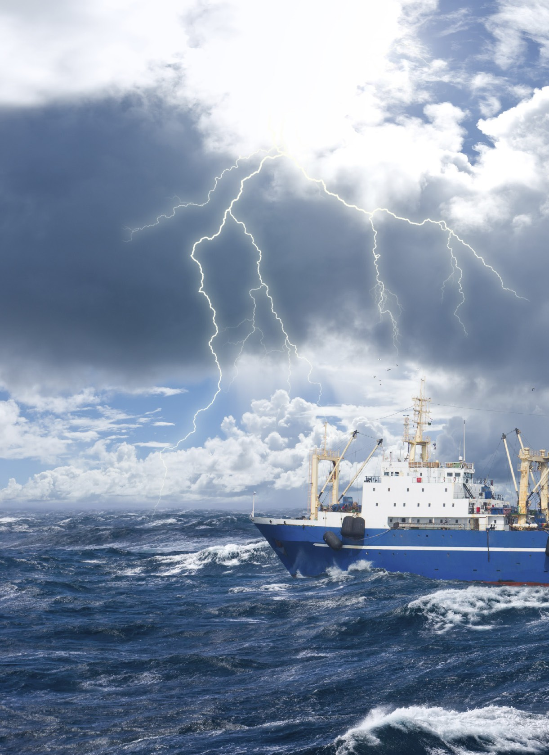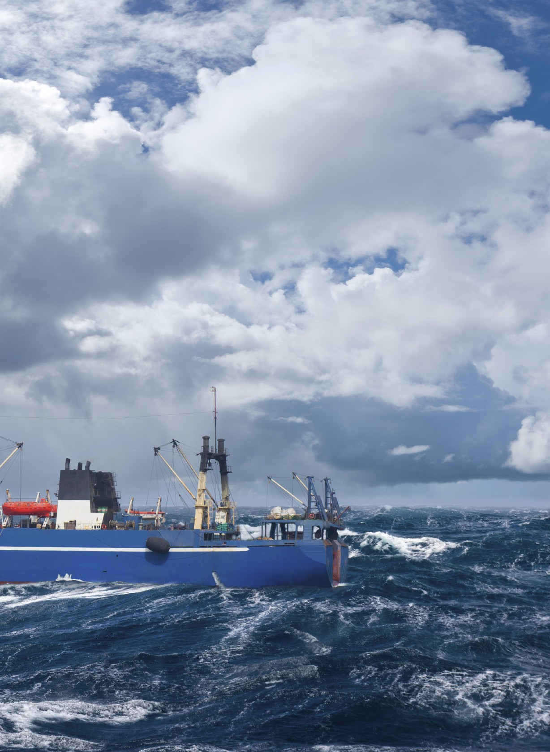

**Loss Prevention**

The Loss Prevention unit is placed within Strategic Business Development & Client Relationship and provides active loss prevention support, analysis, reports as well as advice to members.

**Lars A. Malm**



Director, Strategic Business Development &

Client Relationship

**Telephone:** +46 31 638 427

**E-mail:** [lars.malm@swedishclub.com](mailto:lars.malm@swedishclub.com)

**Joakim Enström**



Loss Prevention Officer

**Telephone:** +46 31 638 445

**E-mail:** [joakim.enstrom@swedishclub.com](mailto:joakim.enstrom@swedishclub.com)

**Anders Hultman**



Loss Prevention, Project Coordinator

**Telephone:** +46 31 638 426

**E-mail:** [anders.hultman@swedishclub.com](mailto:anders.hultman@swedishclub.com)



# Contact

**Head Office Gothenburg**

Visiting address: Gullbergs Strandgata 6 411 04 Gothenburg

Postal address: P.O. Box 171 401 22 Gothenburg, Sweden

Tel: +46 31 638 400, Fax: +46 31 156 711

E-mail: [swedish.club@swedishclub.com](mailto:swedish.club@swedishclub.com)

**Emergency: +46 31 151 328**

**Piraeus**

5th Floor, 87 Akti Miaouli, 185 38 Piraeus, Greece

Tel: +30 211 120 8400, Fax: +30 210 452 5957

E-mail: [mail.piraeus@swedishclub.com](mailto:mail.piraeus@swedishclub.com)

**Emergency: +30 694 453 0856**

**Hong Kong**

Suite 6306, Central Plaza, 18 Harbour Road, Wanchai, Hong Kong

Tel: +852 2598 6238, Fax: +852 2845 9203

E-mail: [mail.hongkong@swedishclub.com](mailto:mail.hongkong@swedishclub.com)

**Emergency: +852 2598 6464**

**Tokyo**

2-14, 3 Chome, Oshima, Kawasaki-Ku, Kawasaki, Kanagawa 210-0834, Japan

Tel: +81 44 222 0082, Fax: +81 44 222 0145

E-mail: [mail.tokyo@swedishclub.com](mailto:mail.tokyo@swedishclub.com)

**Emergency: +81 44 222 0082**

**Oslo**

Tjuvholmen Allé 17, 0252 Oslo, Norway

Tel: +47 9828 1822

E-mail: [mail.oslo@swedishclub.com](mailto:mail.oslo@swedishclub.com)

**Emergency: +46 31 151 328**

Produced by PR Offset, 1406MB